DATA FLOW DIAGRAM
System Data Flow and Booking Process
MERN Full-Stack Web Application
MongoDB • Express.js • React.js • Node.js

1. Purpose
This document describes how information moves through the MERN Movie Booking System. It identifies the external users, frontend, backend processing, database, and optional third-party services. The diagrams represent a proposed design and should be aligned with the features actually implemented.

2. System Context
The customer uses the React interface to browse movies, choose a show, select seats, and create a booking. The administrator uses protected screens to maintain movie and show information. The frontend communicates with the Express API over HTTPS using JSON. The API validates requests and applies business rules before reading or updating MongoDB.
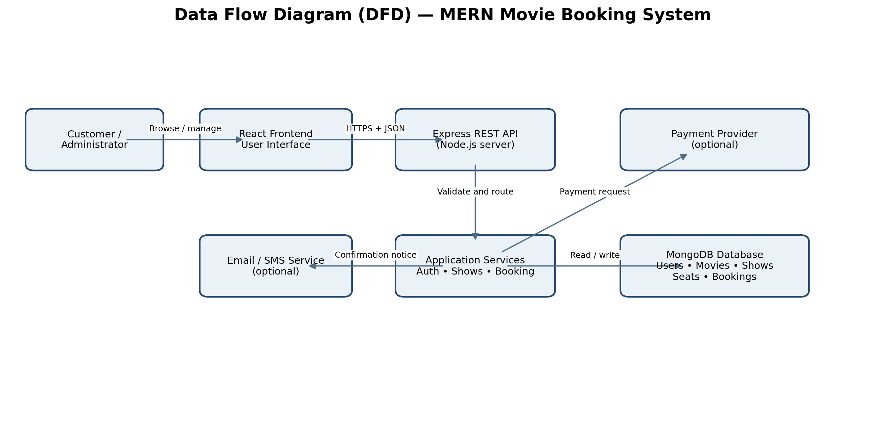

3. Data Flow Explanation
- Customer / Administrator → React Frontend: the user submits search criteria, login details, show selections, seat selections, or administration changes.
- React Frontend → Express REST API: the browser sends an HTTP request containing the required data. Protected requests include the configured authentication credential.
- Express API → Application Services: routes check the request format, authenticate the caller, verify role permissions, and invoke the correct business operation.
- Application Services ↔ MongoDB: the backend retrieves movie/show details and creates or updates users, show schedules, seat reservations, and booking records.
- Application Services → Payment Provider (optional): the backend initiates payment and verifies the result using the provider's supported server-side confirmation mechanism.
- Application Services → Email/SMS Service (optional): after the booking reaches the appropriate successful state, the system can send a confirmation.
- API → React Frontend: the server returns structured success or error data. The interface shows movie results, available seats, booking reference, or an actionable error message.

4. Booking Process Flow
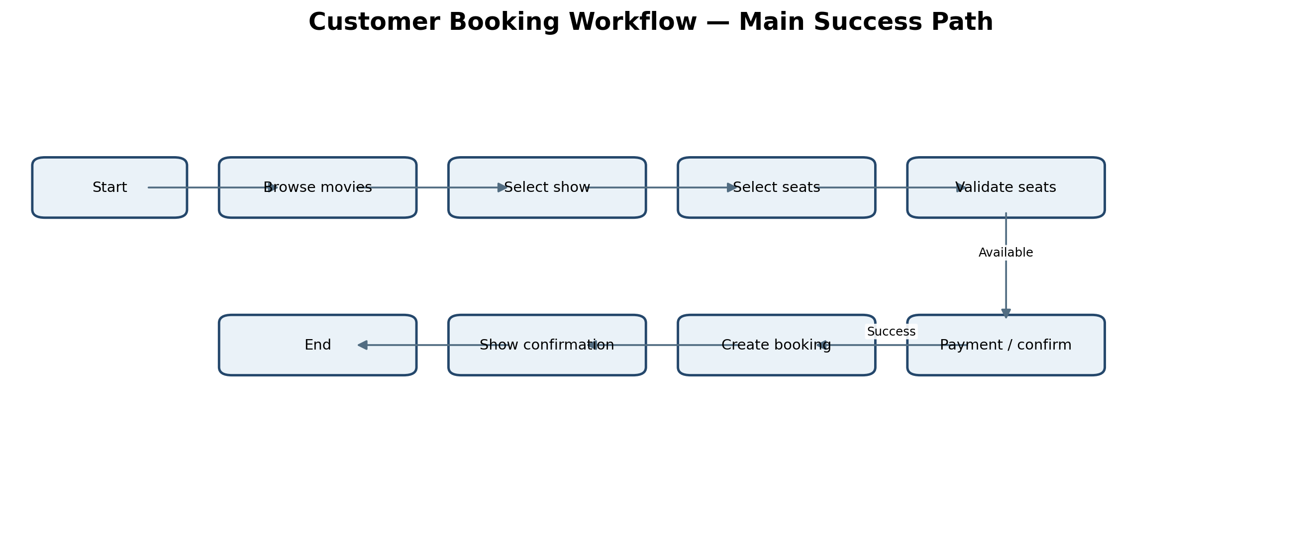

5. Step-by-Step Booking Sequence
- 1. The customer opens the application and browses published movies.
- 2. The customer selects a movie, cinema (if supported), date, and showtime.
- 3. The application requests the seat map and current seat availability from the backend.
- 4. The customer selects one or more seats and proceeds to confirmation.
- 5. The backend re-checks seat availability and calculates the price from trusted server-side data.
- 6. If seats remain available, the backend safely reserves them and creates a booking in the appropriate initial state.
- 7. If payment is enabled, the payment result is verified. Otherwise, the configured booking confirmation rule is applied.
- 8. The system stores the final booking status, returns a unique booking reference, and displays confirmation. Notifications may be sent if configured.

6. Data Stores
Data store | Purpose | Example data
Users | Account and role information | Name, email, password hash, role
Movies | Movie catalogue | Title, genre, duration, language, poster
Cinemas / Screens | Venue and seat layout | Cinema name, screen ID, seat IDs
Shows | Scheduled screenings | Movie, screen, start time, price
Bookings | Reservation records | User, show, seats, amount, status, reference
Payments (optional) | Payment transaction state | Provider reference, amount, status

7. Data Integrity and Error Paths
- If a selected seat is no longer available, the backend rejects the booking attempt and the UI refreshes seat availability.
- If authentication or authorization fails, the API returns an appropriate error and does not perform the protected operation.
- If payment fails or remains pending, the booking must not be shown as paid/confirmed unless the business rules explicitly allow it.
- Seat allocation must be protected against simultaneous requests, using an atomic update, transaction, or equivalent safe reservation approach.
- Errors should be logged for support without exposing passwords, access tokens, or payment secrets.

8. Diagram Notes
Solid arrows indicate the principal information flow. Payment and messaging services are optional integrations, not mandatory parts of the MERN stack. This is a high-level logical DFD; a more detailed Level 1 DFD can be created if your project requires individual processes such as authentication, show management, seat locking, payment verification, and ticket generation.

